Practical 3: Restoration of Noise Images

Bibek Manandhar

20070282

BE-CMP

EEC

30/01/2024

**Summary:**

This practical explores the implementation of mean and median filters in Java for the restoration of noisy images. Testing on images corrupted by several types of noise, the filters' effectiveness was visually inspected. Additionally, the mean square signal-to-noise ratio was calculated for noise-free image pairs, providing a measure of filter performance.

Keywords— Convolution, Enhancement, Java, Spatial filter

1. PROBLEM DESCRIPTION

In this practical, the goal was to implement mean and median filters for restoring images corrupted by

several types of noise. The task involved visually inspecting the results after applying these filters and

quantitatively assessing their performance using the mean square signal-to-noise ratio.

II. THEORITICAL BACKGROUND

A. Mean Filter:

The mean filter is a spatial filter used for noise reduction in images. It calculates the average intensity

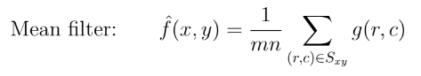value of pixels in a local neighbourhood. The formula for mean filter is given by:

B. Median Filter

The median filter replaces each pixel's intensity with the median value of its neighbourhood. It is

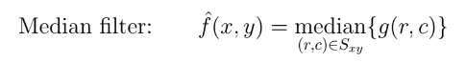particularly effective in preserving edges. The formula for the median filter is given by:

C. Signal-to-Noise Ratio (SNR):

To quantitatively assess the performance of the filters, the mean square signal-to-noise ratio (SNRms) wascalculated for each image pair (noisy-noiseless) and each filter. The SNRms is defined as follows:

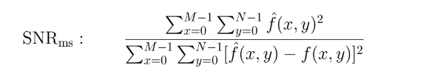

III.RESULTS AND LESSONS LEARNT

In the testing phase, mean and median filters were applied to images corrupted by several types of noise including "messi_N.jpg," "ronaldo_N.jpg," and "ronaldo_de_lima_N.jpg." The combination of visual inspection and quantitative analysis, including SNR, played a vital role in evaluating the filter's

performance.

Mean Filter: Smoothed images, reduced overall noise, blurred images

Median Filter: Preserved edges, did not blur images, not effective against huge noise

We discovered that choosing the right filter requires a thorough understanding of the traits of various noise kinds. An important factor in determining how well the filter performed in relation to various images was visual inspection.

PROGRAM LISTING

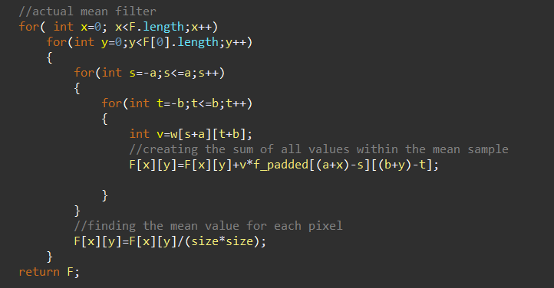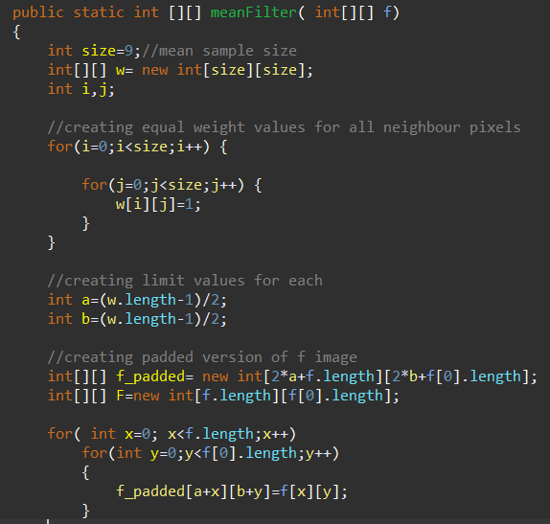//Mean Filter Implementation

Figure : Mean Filter Implementation

//Median Filter

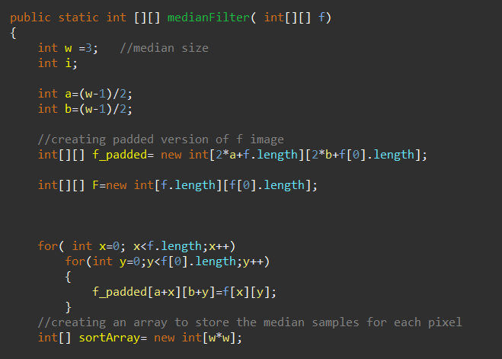

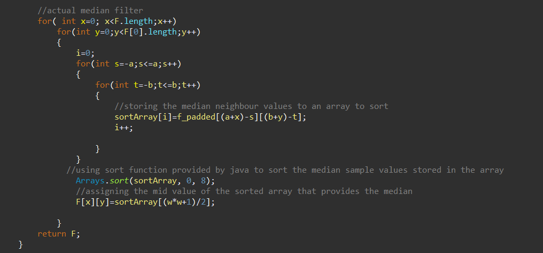

Figure : Median Filter

//SNR Calculation

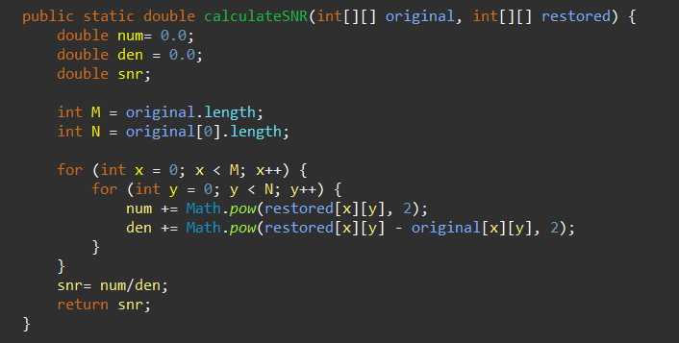

Figure : SNR Calculation